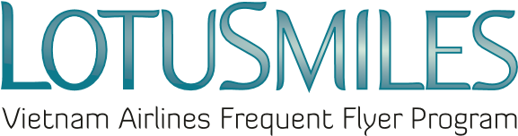

PURCHASE REQUEST FOR BONUS MILES

Buyer’s full name: ______________________________________________________________________________________
Mailing address: _______________________________________________________________________________________
Email: ______________________________________________________ Telephone: _______________________________
Mile receivers’ membership No.: _______________________________________________________________________
Mile receivers’ full name: _______________________________________________________________________________

Purchase amount of bonus miles: ______________________________

CONDITIONS:
- Purchased bonus miles are not used for tier qualification.
- Purchased bonus miles are non-refundable.
- Rates are VND 550,000/1,000 miles (VAT not included) for transactions conducted within Vietnam or USD 25/1,000 miles for transactions made outside Vietnam.
- Bonus miles can be purchased in units of 1,000 miles.
- Price and conditions may be changed at any time without prior notice.

Pay at Vietnam Airlines office: ______________________________
I agree with the above conditions:

_____ _______ ______ ______________________________
Date Month Year Buyer/Member’s signature

