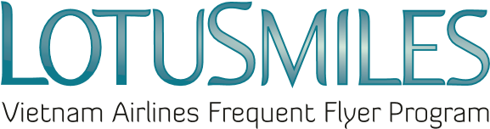

CONVERT BONUS MILES REQUEST
MEMBER’S FULL NAME
Email: _____________________________________Telephone: __________________________________
Membership No.: _______________________________________________________________________

Request to convert …………………………………………….bonus miles to:

☐ ……………………………qualifying miles or ☐ ………………………… qualifying segments

CONDITIONS:
- The conversion rate is: 15,000 bonus miles = 1,000 qualifying miles or 01 qualifying segment.
- If the transaction is conducted outside Vietnam, the processing fee is US$ 10 per transaction.
- If the transaction is conducted within Vietnam, the processing fee is VND 210,000 per transaction (VAT not included).
- Converted qualifying miles can be used for award redemption per Lotusmiles policies.
- Price and conditions may be changed at any time without prior notice.

Process transaction at Vietnam Airlines office: …………………………………………………………

☒ I agree with Lotusmiles terms and conditions and the Privacy Policy of Vietnam Airlines

Member’s signature

Date: / /

